|  |
| --- |
| **MINISTRY OF EDUCATION AND TRAINING** **FPT UNIVERSITY (CAN THO CAMPUS)**  **INFORMATION TECHNOLOGY DEPARTMENT**  **JAVA DESKTOP PRJ311 ASSIGNMENT**  **SOFTWARE ENGINEERING MAJOR**  *SUBJECT*  **AN EWALLET APPLICATION WIBUU PAY**  Student: Nguyen Duc Tong  ID: CE140196  Student: Quan Duc Loc  ID: CE140037  Student: Tran Minh Thang  ID: CE140085  Can Tho, March 27th, 2020 |

# **SPECIAL THANKS**

### Mr. Luong Hoang Huong (Master of Information System) for giving guidance and supporting us in doing this assignment.

### Mr. Quach Luyl Da (Master of Information System) for helping us to have more time to do this assignment.

### Phan Le Trong Nghia for giving courage and supporting us in many ways, especially in giving the documentation guide video.

### Tran Anh Van for designing application icons/images, which drastically improves the overall look and feel for the application.

Even though our group members have tried our best to complete the project satisfactorily, we still encounter many problems all the way to assignment completion due to the lack of knowledge regarding programming with Microsoft JDBC SQL Driver and Remote Method Invocation in Java. Hence, the subtle problems that have arisen during the process of assignment development is inevitable. Hopefully we will receive the valuable, constructive feedback from lecturers as well as our peers in order to make the assignment more perfect and usable.

Our group members are all grateful for everyone’s help in this project! We couldn’t have completed the assignment without all your help!

# **TABLE OF CONTENTS**

MINISTRY OF EDUCATION AND TRAINING 1

**SPECIAL THANKS** **2**

**TABLE OF CONTENTS** **3**

**TERMS, ACRONYMS** **4**

**ABSTRACT** **6**

**INTRODUCTION** **7**

I. Problem Statement 7

II. Assignment Goals 8

III. Subjects and Scope of the Study 8

IV. Research Content 8

V. Main contribution of this assignment subject 9

V.1 About Theory 9

V.2 About Product 9

VI. Document Layout 9

**CONTENT** **10**

I. Problem Definition. 10

I.1. Theoretical Basis 10

I.1.1. Java Programming Language 10

I.1.2. Apache POI 10

I.1.3. JDBC driver 10

I.2. Problem Definition 10

I.3. Problem Analysis 10

I.3.1 Product functions: 10

II. Design and Implement Solution 11

II.1 Design system 11

II.1.1 Introduction 11

II.1.2 System overview 11

II.1.3 System structure 11

III. CHAPTER 3 - TESTING AND ASSESSMENT 13

III. 1 TESTING 13

III.1.1 Target 13

II.1.2 Scope 13

II.2 TESTS 13

II.2.1 Test 1 : Login 13

II.2.2 Test 2 : Register 14

II.2.3 Test 3 : Deposit 15

II.2.4 Test 4 : Withdraw 15

II.2.5 Test 5 : Transfer 16

II.2.6 Test 6 : Pay tuition 17

II.2.7 Test 7 : Top up mobile account 17

II.2.8 Test 8 : Change information 18

II.2.9 Test 9 : Change password 19

II.2.10 Test 10 : Delete account 19

II.2.11 Test 11 : Report 20

II.2.12 Test 12 : Export Report 20

# 

# 

# 

# 

# 

# 

# 

# 

# 

# 

# 

# 

# 

# 

# **TERMS, ACRONYMS**

# 

|  |  |
| --- | --- |
| **Terms/Acronyms** | **Meaning** |
| DB | Database |
| UI | User Interface |
| OS | Operating System |

# 

# 

# 

# 

# 

# 

# 

# 

# **LIST OF TABLES**

Table 1. Input for test cases 1

Table 2. Output for test cases 1

Table 3. Input for test cases 2

Table 4. Output for test cases 2

Table 5. Input for test cases 3

Table 6. Output for test cases 3

Table 7. Input for test cases 4

Table 8. Output for test cases 4

Table 9. Input for test cases 5

Table 10. Output for test cases 5

Table 11. Input for test cases 6

Table 12. Output for test cases 6

Table 13. Input for test cases 7

Table 14. Output for test cases 7

Table 15. Input for test cases 8

Table 16. Output for test cases 8

Table 17. Input for test cases 9

Table 18. Output for test cases 9

Table 19. Input for test cases 10

Table 20. Output for test cases 10

Table 21. Result for test cases 11

Table 22. Result for test cases 12

# **LIST OF IMAGES**

P1. Overall system architecture

P2. Use-Case Diagram

P3. Login Form

P4. Register Form

P5. User Menu

P6. Admin Menu

P7. Deposit Transaction

P8. Withdraw Transaction

P9. Transfer Transaction

P10. Pay Tuition

P11. Change Info

P12. Change Password

P13. Delete Account

P14. Transaction History

P15. Deposit Report

P16.Withdrawal Report

P17. Transfer Report

P18. Export to Excel

P19. Choose new account role when create new user(Admin)

P20. Suspend user

P21. Confirm if admin want to suspend account

P22. Message after suspended

# 

# **ABSTRACT**

There are currently many advances in technology and the technology itself has impacted the world in various aspects, especially our daily lives. We do not need to use the products, let’s say cassette players, analog television, and fax machines, any longer. Such obsolete products are now almost completely replaced by MP3 players, digital television, and emails accordingly. The world around us provides us more and more options to replicate the current products, sometimes even by the state-of-the-art inventions, either by brand new start-ups, or renowned companies and incorporations, bring up the total amount of commodities for us to an endless extent.

However, regarding payment options, there are not really that abundance of alternatives to choose from, notably in online payments. Most of the time, there are scarcely any outstanding options to pick, making it virtually troublesome for users to decide. For instance, on Play Store, there are only a few options for you to pay: using Visa/Mastercard, via PayPal or your mobile career (abolished) and MoMo Ewallet. For young people, who are not yet at 18 to use other payment methods, MoMo is actually a viable pick. Nevertheless, it may be overwhelming for new users to work with, apart from using simple transaction functions such as Deposit, Withdraw and Transfer.

In order to solve one of the most critical issues regarding Ewallet, our group has decided to work on a brand new variation of Ewallet, which provides only a minimal amount of useful functions - an implementation simple enough that even the new users will find it pleasant to use. The assignment ''An ewallet application Wibuu Pay'' introduces all to an ewallet desktop application called ''Wibuu Pay''. This product - including 2 applications for Client and Server side - is written using Java programming language on NetBeans IDE 8.2, with Microsoft JDBC Driver 8.2 for SQL Server and Java Swing to design UI.

# **INTRODUCTION**

## I. Problem Statement

Payment methods have become more diverse for customers across the globe. People nowadays are not required to bring cash when going out to pay for the bills, or their shopping activities. There are many ways to replicate cash, to illustrate, there are other online payment options such as cards, PayPal, and methods using biometric data such as one’s eyes or fingerprints to authenticate is no longer a sci-fi scene as it is more prevalent, exceptionally in developing countries such as China. In addition, not using physical cash can help people to reduce ways to get infected (remarkably during pandemic as current COVID-19), and also such payment methods are more secure in many other aspects, making purchases both easy and safe.

However, online payment has always been a problem for many users. There are not only just a few options, but also, observably, a number of them have completely stopped working, due to many reasons including financial problems, violating a nation’s laws, etc. and some have complicated UI in accompaniment with abundance features, making the process of usage difficult. Those factors are what lead users to no choice but to use a payment method that they do not like.

Understanding the current scenario, to satisfy more people’s needs, it is a must to implement more options in addition to current online payment methods, especially ewallets. This will help people to get rid of their concerns regarding online payment methods, particularly having only a minimal amount of useful functions.

# 

## II. Assignment Goals

This assignment goal is to develop and create a simple ewallet desktop application, which is user-friendly and provides UI for both Admin and User. The application will allow users to do transaction-related functions (deposit, withdraw, transfer, transaction history), account info management (change info, password, delete account, reset password) or other functions such as pay tuition, top up mobile account and see account balance. Likewise, in the admin UI, the application allows them to generate transaction reports (deposit/withdraw/transfer reports) and manage user account management (create new account for admin/user, suspend a user). All data will be stored using SQL Server 2016. UI will be designed using Java Swing. Database connection uses Microsoft JDBC Driver 8.2 for SQL Server. Code written using Java programming language on NetBeans IDE 8.2 for both Client and Server side.

Assignment product is an ewallet desktop application namely “Wibuu Pay”, which is an implementation of an ewallet online payment method.

## III. Subjects and Scope of the Study

The subjects for this assignment are students or other subjects who have enthusiasm, passion or the demand to study about Java Swing, connecting to SQL Server databases using Microsoft JDBC driver 8.2, etc.

The scope of study for this assignment is the theoretical basis of creating a desktop application for both Client and Server sides using Java programming language on NetBeans IDE 8.2, designing its UI using Java Swing, connection to SQL Server 2016 database using Microsoft Microsoft JDBC driver 8.2.

## IV. Research Content

Main content of the subject of this assignment:

* Program with Java programming language on NetBeans IDE 8.2.
* Designing UI using Java Swing.
* Connect to SQL Server database in Java using JDBC Driver.
* Access and modify database data using queries.
* Apache POI - Java API to export Java JTable data into Excel file.
* Add icons into buttons in Java

## V. Main contribution of this assignment subject

### V.1 About Theory

Contributions of assignment subject:

* Knowledge to program in Java using NetBeans IDE 8.2.
* Knowledge to program with Apache POI.
* Knowledge to connect to SQL Server database in Java using JDBC Driver.
* Knowledge to design UI using Java Swing
* Knowledge to access and modify databases via queries sent from Java applications.
* Knowledge to add icon into buttons in Java

### V.2 About Product

Is an application designed to use for a small scope of users. Satisfy the demands regarding real life problem solutions.

## VI. Document Layout

Document Layout consists of 3 parts:

* Introduction: includes Problem Statement, Assignment Goals, Subjects and Scope of the Study as well as Research Content and Main Contributions of this Assignment Subject.
* Content: contains 3 chapters - first chapter is Problem Definition, second chapter is Design and Implement Solution, third chapter is Testing and Assessment.
* Conclusion: states the achievements, shortcomings and development potentials of this assignment subject.
* Finally, there will be references and appendix.

# **CONTENT**

## I. Chapter 1 - Problem Definition.

### I.1. Theoretical Basis

#### I.1.1. Java Programming Language

Java Programming Language is Object Oriented. Unlike other programming languages, when Java is compiled, it is compiled into platform independent bytecode. This bytecode is interpreted by the Virtual Machine (JVM) on whichever platform it is being run on., Simple, Secure, Architecture-neutral, Portable, Robust, Multithreaded, Interpreted, High Performance, Distributed, and Dynamic. It was developed by Sun Microsystems, initiated by James Gosling, and released in 1995.

#### I.1.2. Apache POI

Apache POI is a popular API on Java that allows Java to create, modify, and display MS Office files. It is an open-source library developed and distributed by Apache Software Foundation containing classes and methods to decode the user input data or a file into MS Office documents.

#### I.1.3. JDBC driver

JDBC refers to the Java Database Connectivity. Providing java API that allows Java programs to access database management systems (relational database). The JDBC API contains a set of interfaces and classes enabling java programs to execute SQL statements. Interfaces and classes in JDBC API are written in java.

### I.2. Problem Definition

#### I.2.1 Introduction

1. Target

The target of this section is to provide the overall information for readers about the application based on its function description and specifically describe each function to demonstrate the relationship among the product’s components.

Is a fundamental documentation for analysis, comparison for further stages of design, development and maintenance of product.

This section aims at the following reader groups: designers, programmers, testers, maintenance staff and every other person who wants to dive deep into the operation of the product.

1. The Product’s Scope

The product comprises a desktop application and database SQL file. It allows a user to login to server through/via client-side and access the functions dependent on whether he or she is a user or admin. For a user, there will be transaction-based functions and account info management. For an admin, there will be creating reports function and user management.

1. Document Layout

The layout of this document is composed of overall description, the outside application communication requirements, functions, non-functions of the product, solution choice and solution analysis.

Parts of the document are made to be appropriate for the following group of users’ purposes:

* Group 1: programmers should read the communication requirements, functional requirements.
* Group 2: designers should read all parts of this chapter.
* Group 3: testers should read the application functions and non-functional requirements.
* Group 4: users should read the outside application communication requirements.

#### I.2.2 Overall Description

1. Product Background

The Ewallet applications have become more prevalent such as MoMo, ViettelPay, ZaloPay, etc. It is a breath of fresh air in mobile payment methods as well a trendy subject for passionate researchers or interested students.

The product consists of the Ewallet desktop application Wibu pay for Client-side as well as Server-side, and SQL Server DB.

1. Product Functions

* For an ordinary user, the application grants them access to perform:
* Transaction-related functions (deposit, withdraw, transfer, pay tuition, top up mobile account)
* Account info management functions (change info, password, reset password, delete account, view transaction history)
* Export transaction history into an Excel file.
* For an admin, the application will allow them to:
* Create reports (deposit/withdraw/transfer reports)
* Export the reports (deposit/withdraw/transfer) to Excel files.
  + - User-management functions (create new user, suspend user).

1. User Characteristics:

Users must have basic knowledge for using desktop applications.

1. Operating Environment

* Application operates on computers with Intel Core processors and up.
* Operating System: Windows 8 and up.
* Installed NetBeans IDE or other IDEs that support Java programming language (for both the client and server sides).

1. Execution and Design Constraints

* Execution Constraints:
* Server-side application must be connected to database when ran
* Execution must be quick and accurate upon user requests.
* Design Constraints:
* Friendly UI.
* Appropriate and clear font size.
* Graphical components are correctly aligned (visually appealing).

1. Constraint Assumptions

* Data in DB must be backed up frequently to avoid incidents causing data loss.
* Do not tamper with anything in installation path/program path or else the product may not work properly.

#### I.2.3 Outside communication requirements

1. Hardware Communication

User’s desktop requirements: minimum Intel Core 2 1,8GHz and sufficient disk space for storing the product.

1. Software Communication

* Installed OS: Windows 8 and up.
* Pre-installed NetBeans IDE 8.2 or other IDEs that support Java programming language (for both the client and server sides).

1. Media Communication

### I.3. Problem Analysis

#### I.3.1 Product Functions:

Categorizing priority of product functions into 3 levels: High, Medium, and Low.

* **High:** high priority functions are functions that play the foremost important role in the application. It directly affects the functionality of the product. If these functions are broken, the product could not work at all.
* **Medium:** medium priority functions play some important role in the functionality. If these functions are broken, the product could not work properly.
* **Low:** low priority functions play the least important role in the functionality. If these functions are broken, the product still works normally.

## II. Chapter 2 - Design and Solution Implementation

### II.1 Design system

### II.1.1 Introduction

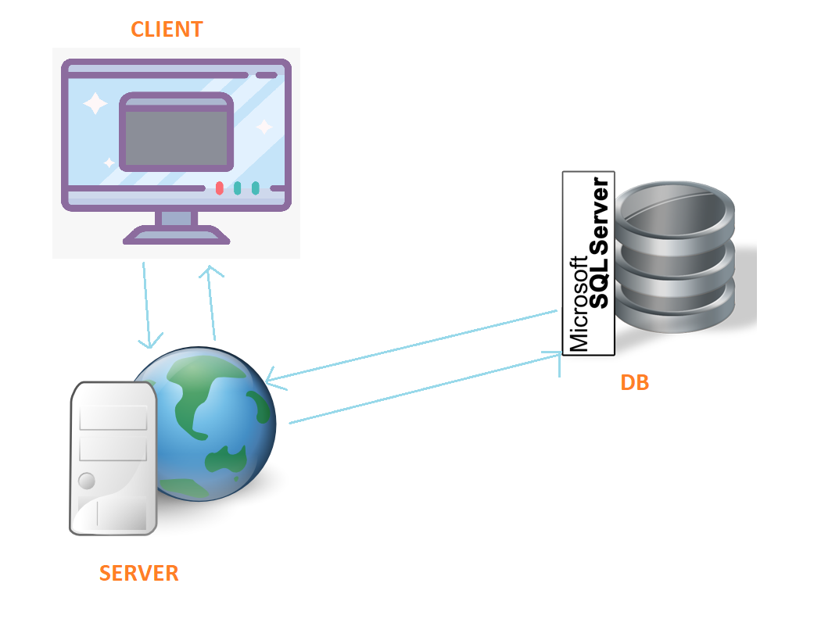

**P1. Overall system architecture**

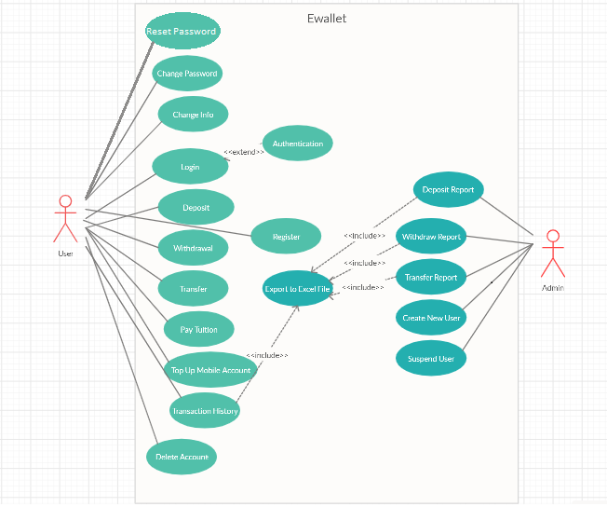

**P2. Use-Case Diagram**

### II.2. Set up solution

#### II.2.1. Main function of system

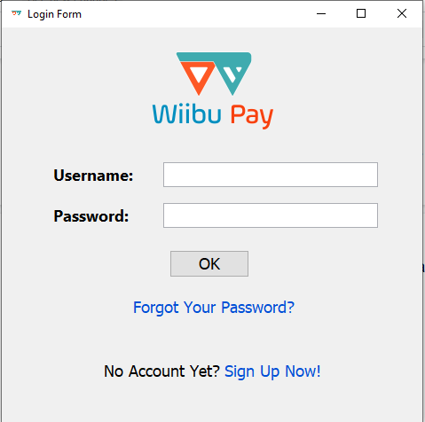

**P3. Login Form**

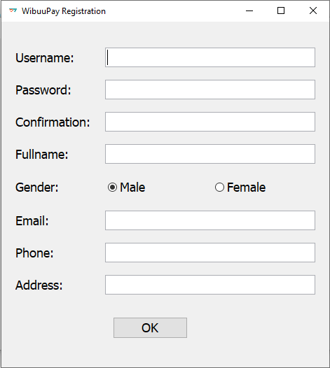

**P4. Register Form**

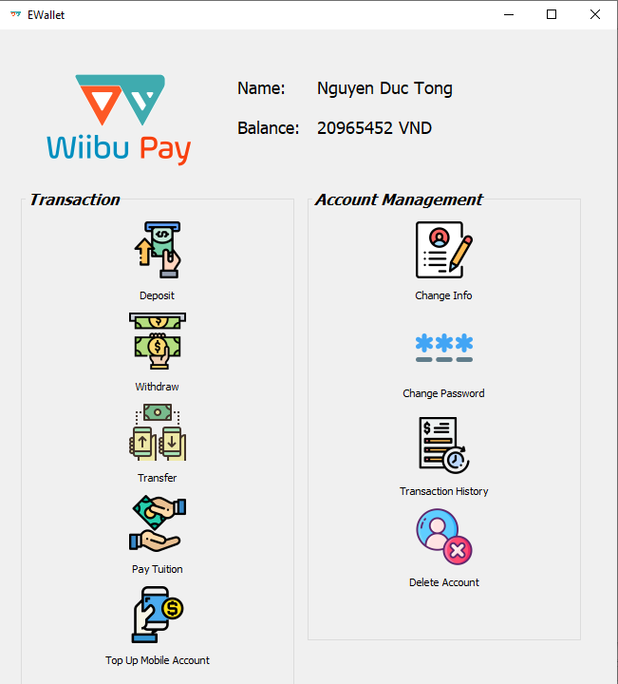

**P5. User Menu**

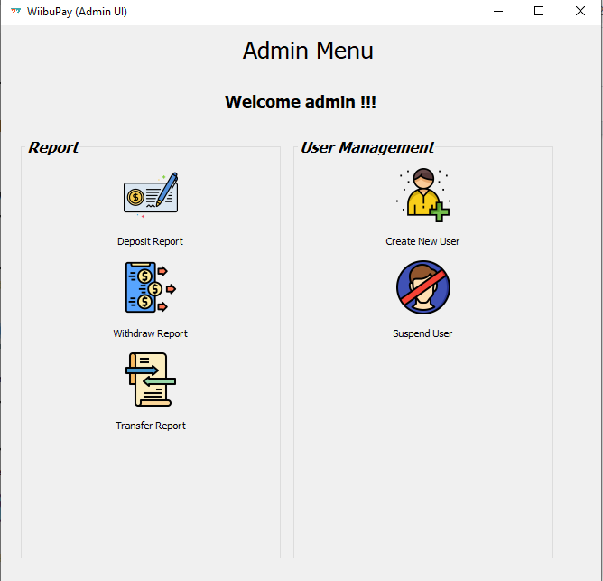

**P6. Admin Menu**

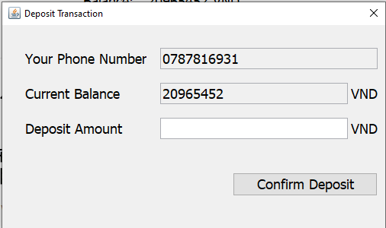

**P7. Deposit Transaction**

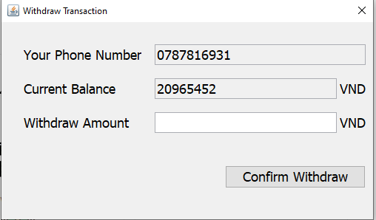

**P8. Withdraw Transaction**

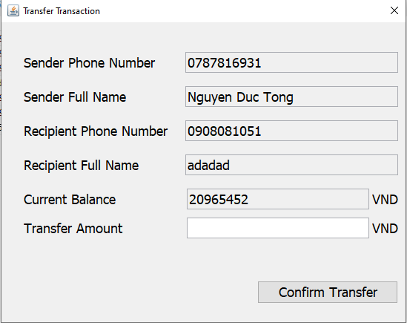

**P9. Transfer Transaction**

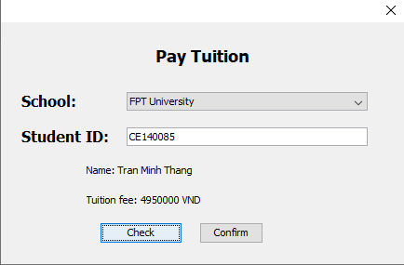

**P10. Pay Tuition**

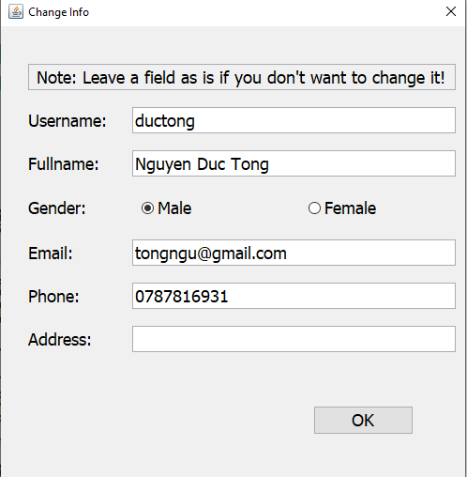

**P11. Change Info**

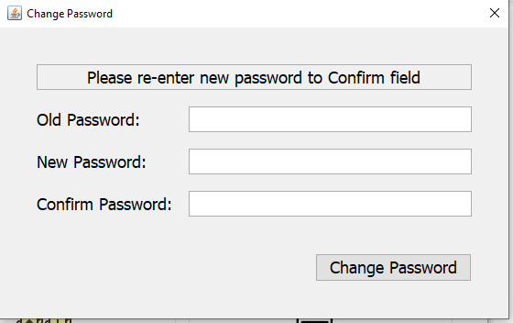

**P12. Change Password**

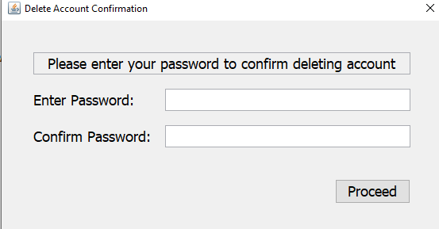

**P13. Delete Account**

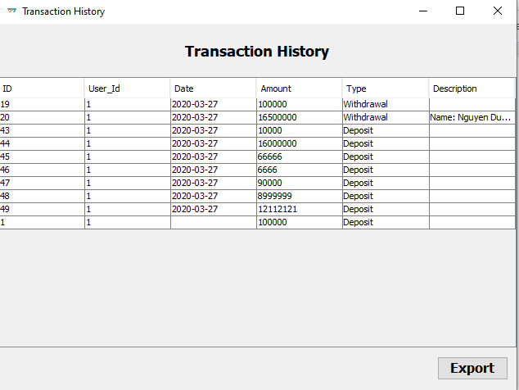

**P14. Transaction History**

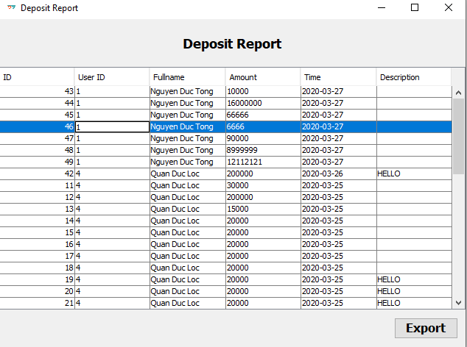

**P15. Deposit Report**

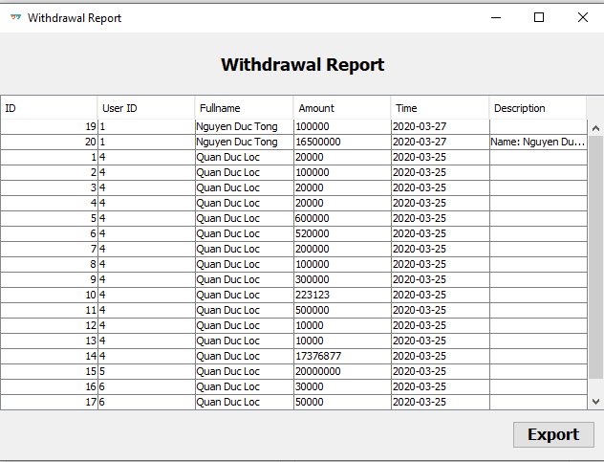

**P16.Withdrawal Report**

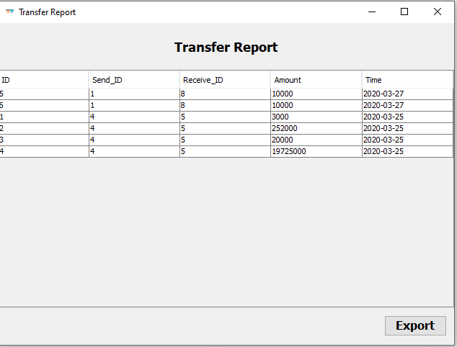

**P17. Transfer Report**

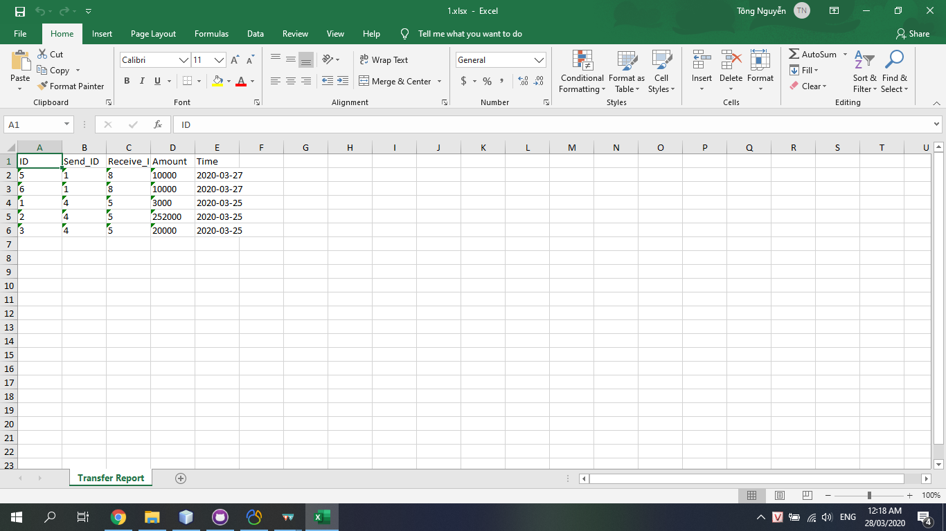

**P18. Export to Excel**

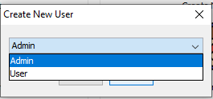

**P19. Choose new account role when create new user(Admin)**

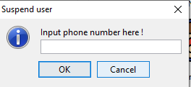

**P20. Suspend user**

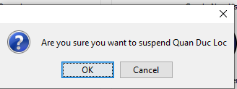

**P21. Confirm if admin want to suspend account**

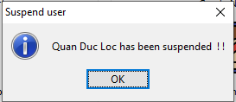

**P22. Message after suspended**

## III. CHAPTER 3 - TESTING AND ASSESSMENT

### III.1 TESTING

#### III.1.1 Target

In order to check that the product is functioning according to the specifications, functions The feature works as expected or not. Presentation of test methods. Find solutions to overcome when an error occurs/

#### III.1.2 Scope

Create and test test cases corresponding to the internal functions specification documents and design documents.

### III.2 TESTS

#### III.2.1 Test 1 : Login

a. Target

In order to find errors during system logins, see if there are any errors in the system if you enter the wrong account or password.

b. Input

|  |  |  |  |
| --- | --- | --- | --- |
| **Case** | **Account** | **Password** | **Value** |
| 1 | ductong | 123 | TRUE |
| 2 | admin | 123 | TRUE |
| 3 | ductong | deptrai | FALSE |
| 4 | ductong |  | FALSE |
| 5 |  | khongcopass | FALSE |
| 6 | ductong | 123 | FALSE |

*Table 1. Input for test cases 1*

c. Output

|  |  |  |
| --- | --- | --- |
| **Case** | **Desired results** | **Success** |
| 1 | You are logged in as a User | x |
| 2 | You are logged in as a Admin | x |
| 3 | Username or Password is Incorrect | x |
| 4 | The password must not be null | x |
| 5 | The username must not be null | x |
| 6 | Your account has been suspended | x |

*Table 2. Output for test cases 1*

#### II.2.2 Test 2 : Register

1. Target

In order to find errors during the system registration process, see if there are errors in the case of entering the same username, phone number, missing information.

1. Input

|  |  |  |
| --- | --- | --- |
| **Case** | **Inputted information** | **Value** |
| 1 | NULL ALL | FALSE |
| 2 | Duplication phone number | FALSE |
| 3 | Duplication phone username | FALSE |
| 4 | FULL INFO | TRUE |
| 5 | Lengths of phone number different 10 ,not a number | FALSE |

*Table 3. Input for test cases 2*

1. Output

|  |  |  |
| --- | --- | --- |
| **Case** | **Desired results** | **Success** |
| 1 | The username must not be null | x |
| 2 | Phone number already bound... | x |
| 3 | Username already bound... | x |
| 4 | Register successfully | x |
| 5 | Please enter phone number 10 digits | x |

*Table 4. Output for test cases 2*

#### II.2.3 Test 3 : Deposit

1. Target

To identify and make sure the application works in all cases where deposit is invalid during the deposit process.

1. Input

|  |  |  |
| --- | --- | --- |
| **Case** | **Inputted information** | **Value** |
| 1 | Deposit value is NULL | FALSE |
| 2 | 1000<Deposit value <50000000 | TRUE |
| 3 | 1000>Deposit value or Deposit value >50000000 | FALSE |
| 4 | Deposit value is not a number | FALSE |

*Table 5. Input for test cases 3*

1. Output

|  |  |  |
| --- | --- | --- |
| **Case** | **Output information** | **Value** |
| 1 | Please input deposit value | x |
| 2 | Deposit successfully | x |
| 3 | Please enter the value between 1000 and 50000000 | x |
| 4 | Please input deposit value | x |

*Table 6. Output for test cases 3*

#### II.2.4 Test 4 : Withdraw

1. Target

To identify and make sure the application works in all cases where withdraw is invalid during the withdraw process.

1. Input

|  |  |  |
| --- | --- | --- |
| **Case** | **Inputted information** | **Value** |
| 1 | Withdraw value is NULL | FALSE |
| 2 | 1000<Withdraw value <Current balance | TRUE |
| 3 | 1000>Withdraw value or Withdraw value >Current balance | FALSE |
| 4 | Withdraw value is not a number | FALSE |

*Table 7. Input for test cases 4*

1. Output

|  |  |  |
| --- | --- | --- |
| **Case** | **Output information** | **Value** |
| 1 | Please input Withdraw value | x |
| 2 | Withdraw successfully | x |
| 3 | Please enter the value between 1000 and current balance | x |
| 4 | Please input Withdraw value | x |

*Table 8. Output for test cases 4*

#### II.2.5 Test 5 : Transfer

1. Target

To identify and make sure the application works in all cases where transfer is invalid during the transfer process.

1. Input

|  |  |  |
| --- | --- | --- |
| **Case** | **Inputted information** | **Value** |
| 1 | Wrong phone number | FALSE |
| 2 | Input current user phone number | FALSE |
| 3 | 1000>Transfer value or Transfer value >Current balance | FALSE |
| 4 | Transfervalue is not a number | FALSE |
| 5 | 1000<Transfer value <Current balance | TRUE |

*Table 9. Input for test cases 5*

1. Output

|  |  |  |
| --- | --- | --- |
| **Case** | **Output information** | **Value** |
| 1 | Please input phone number of 10 digits | x |
| 2 | Cannot transfer money to yourself | x |
| 3 | Please enter the value between 1000 and current balance | x |
| 4 | Please input transfer value | x |
| 5 | Transfer successfully | x |

*Table 10. Output for test cases 5*

#### II.2.6 Test 6 : Pay tuition

1. Target

To identify and make sure the application works in all cases where paying tuition works wrong during the pay tuition process.

1. Input

|  |  |  |
| --- | --- | --- |
| **Case** | **Inputted information** | **Value** |
| 1 | Student ID null or Wrong | FALSE |
| 2 | Right Student ID | TRUE |
| 3 | Current balance <fee | FALSE |
| 4 | Current balance > fee | TRUE |
| 5 | Tuition fee =0 | FALSE |

*Table 11. Input for test cases 6*

1. Output

|  |  |  |
| --- | --- | --- |
| **Case** | **Output information** | **Value** |
| 1 | Student not found | x |
| 2 | Show Name and Fee | x |
| 3 | Not have enough money | x |
| 4 | Paid successfully | x |
| 5 | Student has paid fee | x |

*Table 12. Output for test cases 6*

#### II.2.7 Test 7 : Top up mobile account

1. Target

To identify and make sure the application works in all cases where topping up mobile accounts works wrong during the top up process.

1. Input

|  |  |  |
| --- | --- | --- |
| **Case** | **Inputted information** | **Value** |
| 1 | Phone number null or wrong | FALSE |
| 2 | Right phone number | TRUE |
| 3 | Current balance < amount want to pay | FALSE |
| 4 | Current balance > amount want to pay | TRUE |

*Table 13. Input for test cases 7*

1. Output

|  |  |  |
| --- | --- | --- |
| **Case** | **Output information** | **Value** |
| 1 | Please input phone number of 10 digits | x |
| 2 | Show Name and Fee | x |
| 3 | Not have enough money | x |
| 4 | Paid successfully | x |

*Table 14. Output for test cases 7*

#### II.2.8 Test 8 : Change information

1. Target

To identify and make sure the application works in all cases where users change his/her info correctly or incorrectly.

1. Input

|  |  |  |
| --- | --- | --- |
| **Case** | **Inputted information** | **Value** |
| 1 | The inputted username has exist in database | FALSE |
| 2 | The inputted phone number has exist in database | FALSE |
| 3 | Username, full name, email or phone number is null | FALSE |
| 4 | Enter all or all but email and not the same username or phone number with other users | TRUE |

*Table 15. Input for test cases 8*

1. Output

|  |  |  |
| --- | --- | --- |
| **Case** | **Output information** | **Value** |
| 1 | Username already exist | x |
| 2 | Phone number already exist | x |
| 3 | Error message | x |
| 4 | Change successfully | x |

*Table 16. Output for test cases 8*

#### II.2.9 Test 9 : Change password

1. Target

To identify and make sure the application works in all cases where users change his/her info correctly or incorrectly.

1. Input

|  |  |  |
| --- | --- | --- |
| **Case** | **Inputted information** | **Value** |
| 1 | Old password correct but new password not match | FALSE |
| 2 | Old password incorrect | FALSE |
| 3 | Old password correct, new password matched | TRUE |

*Table 17. Input for test cases 9*

1. Output

|  |  |  |
| --- | --- | --- |
| **Case** | **Output information** | **Value** |
| 1 | Confirm password not matched | x |
| 2 | Old password incorrect | x |
| 3 | Change successfully | x |

*Table 18. Output for test cases 9*

#### II.2.10 Test 10 : Delete account

1. Target

To identify and make sure the application works in all cases where users delete his/her account.

1. Input

|  |  |  |
| --- | --- | --- |
| **Case** | **Inputted information** | **Value** |
| 1 | Old password correct | TRUE |
| 2 | Old password incorrect | FALSE |

*Table 19. Input for test cases 10*

1. Output

|  |  |  |
| --- | --- | --- |
| **Case** | **Output information** | **Value** |
| 1 | Delete successfully | x |
| 2 | Old password incorrect | x |

*Table 20. Output for test cases 10*

#### II.2.11 Test 11 : Report

|  |  |  |
| --- | --- | --- |
| **Case** | **Type** | **Value** |
| 1 | Deposit | TRUE |
| 2 | Withdraw | TRUE |
| 3 | Transfer | TRUE |

*Table 21. Result for test cases 11*

#### II.2.12 Test 12 : Export Report

|  |  |  |
| --- | --- | --- |
| **Case** | **Type** | **Value** |
| 1 | Deposit | TRUE |
| 2 | Withdraw | TRUE |
| 3 | Transfer | TRUE |

*Table 22. Result for test cases 12*

# **CONCLUSION**

## I. Achievements

* Meet this assignment’s requirements, make a flawless combination of SQL Server 2016 Database Management, Microsoft JDBC Driver and Apache POI Java API.
* Uses the hardware optimally, with reasonable pricing, affordable.
* Researched and made a product which contains a server and client based on the theory about Java, Java Swing, Apache POI and SQL Server 2016.
* Complete ewallet applications (for both client and server sides).

## II. Shortcomings

* The program lacks feature diversity.
* The JOptionPane’s default icons are cropped when displayed for High DPI.
* The code behind somewhat lacks optimization.

## III. Development Potentials

* Improve the feature diversity by adding more features, yet retain the minimalism as well as ease of use based on the demands of users/admins.
* Improve maintenance possibilities as well as code optimization and application scalability.
* Fix the High DPI icons problems by using native Windows icons as replacement to improve look and feel.

# **PREFERENCES**

[1] <https://www.tutorialspoint.com/java/java_overview.htm>

[2] <https://www.tutorialspoint.com/apache_poi/apache_poi_overview.htm>

[3] <https://codesjava.com/jdbc-overview>

[4] Luận văn tốt nghiệp Đại học Cần Thơ, chuyên ngành Kỹ thuật phần mềm, đề tài “Phần mềm quản lý thông tin dịch hại của Thành Phố Cần Thơ” - Tác giả Nguyễn Chí Thiện (Tháng 4 năm 2016).